Shital Sudhakar Metakari.

Mobile No: +91-7218774841

E-mail : shitalsmetakari1524@gmail.com
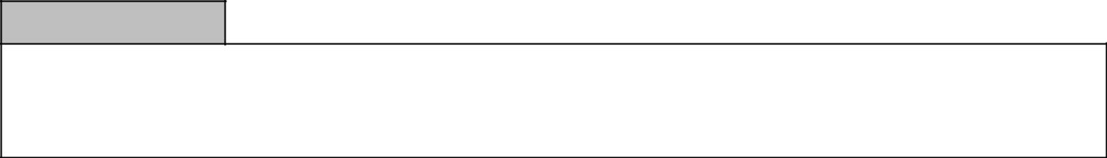

Objective

Aim to learn more and gain knowledge that can be further utilized to accomplish the organizational goals effectively. Looking for a challenging and exciting opportunity, which call upon one’s ability and give a considerable degree of responsibility.


Profile Summary

Good understanding of Software Development Life Cycle and quality processes.
Good knowledge of OOPs,​ C#,C, SQL Server, HTML and​ HP​ ALM.​
Good communication, Presentation, Problem-solving and team working skills.

Able to identify Test Scenarios and Design Test cases, which ensure complete Coverage.
Good understanding of Waterfall,​V-Model and​ Agile​ Methodology.
Ability to understand Functional Requirements and Design Documents.

Knowledge of MS-SQL.

Skill Set
Languages/Technologies: | C#,OOPS concepts, C ,SQL
Front End : | HTML
Tools: | HP ALM 11.0, MS-SQL Server 2012
IDE: | Visual Studio
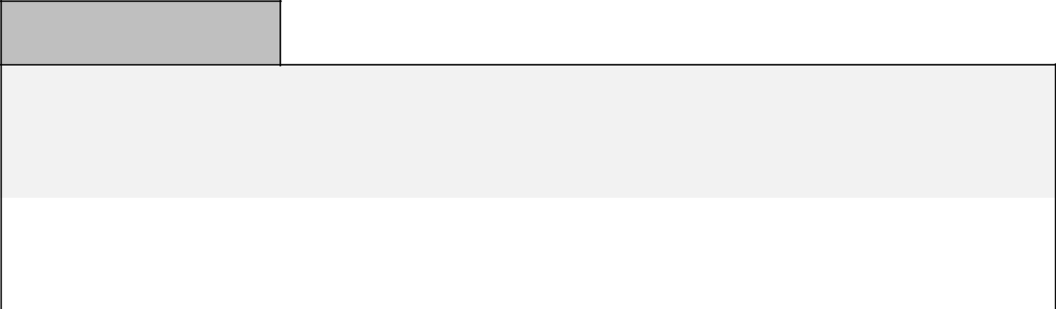

Educational Qualification

BE in Computer Science and Engineering

Course | Year of passing | Board/ | Percentage
Course | Year of passing | University | Percentage
Bachelor of Engineering | May-2019 | Solapur University | 73.08%
HSC | Feb-2015 | Maharashtra | 65.85%
SSC | March- 2013 | Maharashtra | 78.80%

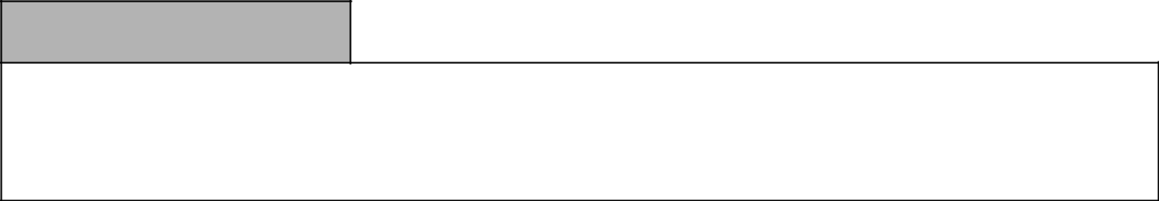

Curricular

Active member of NSS(National Service Scheme)

Visited to ISRO through industrial tour from college in third year.

Active participation in college annual gathering & sports.

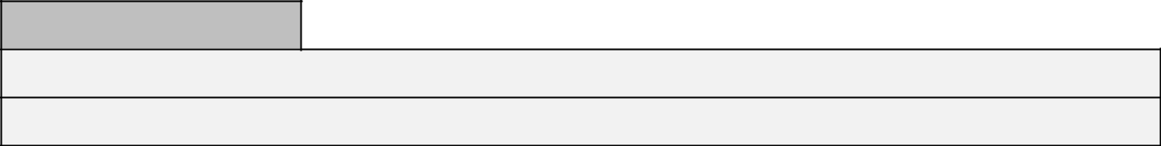

Academic Project Details

Project : “Placement Prediction System By using Machine Learning”

Environment: Python

Personal data
Date of ​Birth | 15th June 1998
Correspondence​Address | A/p-Sharadnagar Tal-Mangalwedha Dist-Solapur(413305)
E-​mail | shitalsmetakari1524@gmail.com
Contact ​No​. | +917218774841
Linguistic Proficiency | English, Hindi, Marathi
Hobbies | Connecting with new people, Listening music.
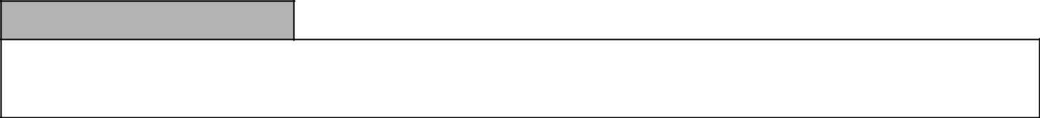

Declaration

I do hereby declare that the particulars of information and facts stated herein above are true, correct and complete to the best of my knowledge and belief.

